**COAL LAB 7**

**21k-4834**

TASK 1

include irvine32.inc

.data

val dword 5

x dword ?

.code

main proc

cmp val, ecx

jl and1

jmp else1

and1:

cmp ecx, edx

jnge else1

mov x, 0

jmp ee

else1:

mov x, 1

ee:

exit

main endp

end main

TASK 2

include irvine32.inc

.data

arr SWORD 0, 0, 0, 0, 1, 20, 35, -12, 66, 4, 0

x byte "Value : ",0

.code

main proc

mov esi, 0

mov ecx, lengthof arr

L1:

cmp arr[esi], 0

jnz found

add esi, 2

Loop L1

jmp ee

found :

mov edx , offset x

call writestring

movzx eax, arr[esi]

call writedec

ee:

exit

main endp

end main

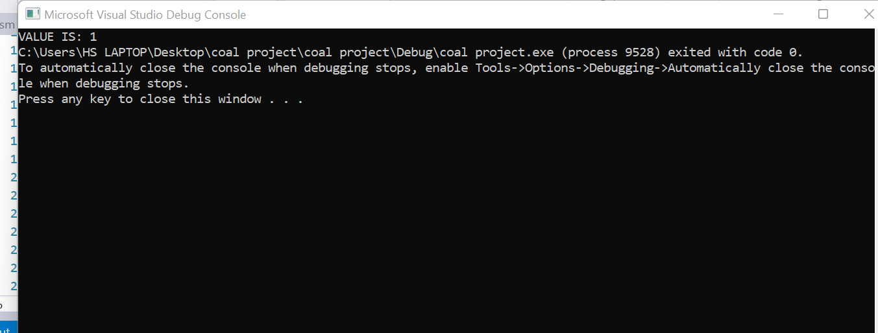

TASK 3

include irvine32.inc

.data

arr DWORD 4 DUP(?)

x word ?

prompt byte " not equal", 0

prompt1 byte "equal", 0

.code

main proc

mov esi , 0

mov ecx, 4

L1:

call readint

mov arr[esi], eax

add esi, 4

Loop L1

mov esi , 0

mov ecx, 3

L2:

mov eax,arr[esi+4]

cmp eax, arr[esi]

je one

two:

mov x, 2

jmp ee

one:

mov x, 1

ee:

add esi, 4

Loop L2

cmp x, 1

je equal

mov edx, offset prompt

call writestring

exit

equal:

mov edx, offset prompt1

call writestring

exit

main endp

end main

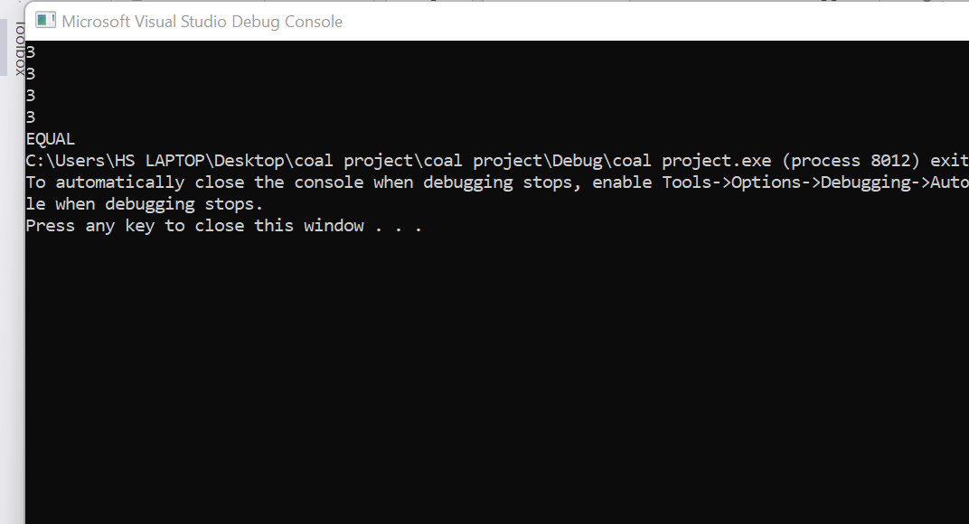

TASK 4

include irvine32.inc

.data

arr WORD 10, 4, 7, 14, 299, 156, 3, 19, 29, 300, 20

prompt byte "not found", 0

prompt1 byte "FOUND", 0

.code

main proc

call readint

mov ecx, lengthof arr

mov esi, 0

L1:

movzx ebx, arr[esi]

cmp eax, ebx

je found

add esi , 2

Loop L1

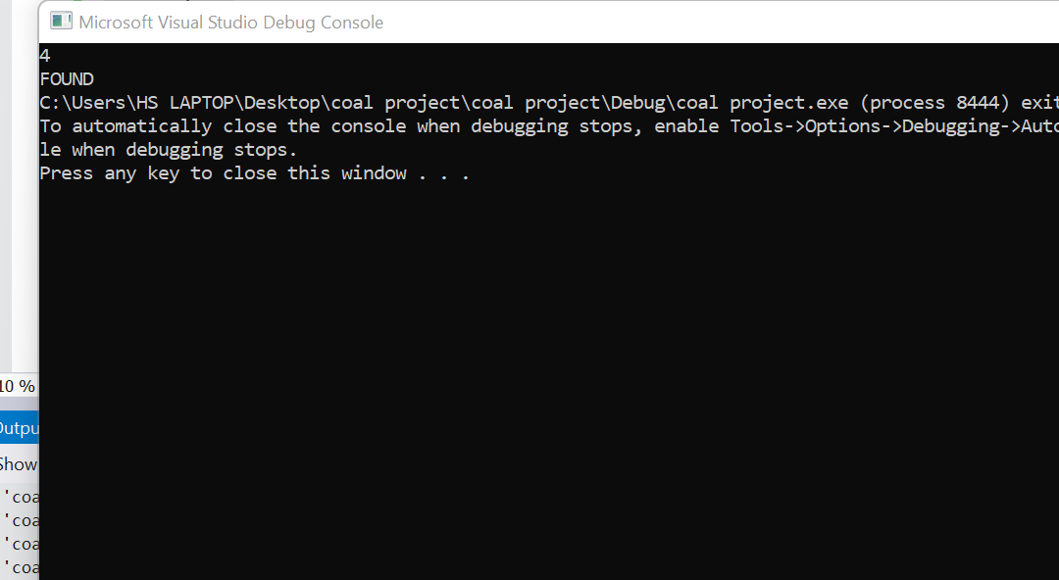

jmp not_found

found:

mov edx, offset prompt1

call writestring

exit

not_found:

mov edx, offset prompt

call writestring

exit

main endp

end main

TASK 5

include irvine32.inc

.data

Swap_Count byte 0

list dword 500 DUP(?)

.code

main proc

call readint

mov ecx, eax

mov ebx, eax

mov esi, 0

call crlf

TARGET:

call readint

mov list[esi], eax

add esi, 4

Loop TARGET

mov ecx, ebx

dec ecx

mov esi, 0

TARGET2:

mov eax, list[esi+4]

cmp list[esi], eax

jg swap

jng endd

swap:

xchg list[esi], eax

xchg list[esi+4], eax

inc Swap_Count

endd:

add esi, 4

Loop TARGET2

movzx eax, Swap_Count

call writedec

exit

main endp

end main